**ONLINE EXAM PORTAL**

**ABSTRACT:**

Conducting a paperless examination is made available by using the concept of web based online examination which was automated processing system for the works which were better than offline mode and reduces the manual work.

Through this web application , it can be possible to conduct examination through internet. It can possible to conduct either objective or subjective type. This subjective type requires human power for checking answers, but objective type is automated process.

Candidates will able to get their results after completing their examination.

Proposed System: This project is based on objective type. The concept of html css are used for designing the pages. Database is used to store student details of registration. Other tools are used based on their requirement.

FLOW DIAGRAM:

PORTAL

RESULT

LOGIN

REGISTERED STUDENTS

CANDIDATE

REGISTRATION

**PROJECT TECHNOLOGY:**

* HTML
* CSS
* Spring And Hibernate
* Java Script
* MySql
* JSP
* Servlets

**OBJECTIVE:**

* The Student first apply for exam and need to enroll for it.
* Student who attend exam has login id and password.
* The Instruction page is displayed before questions.
* Questions get displayed and student can view questions and submit answers
* The result gets appeared after final submit or session gets completed.

HOME PAGE:



LOGIN PAGE:

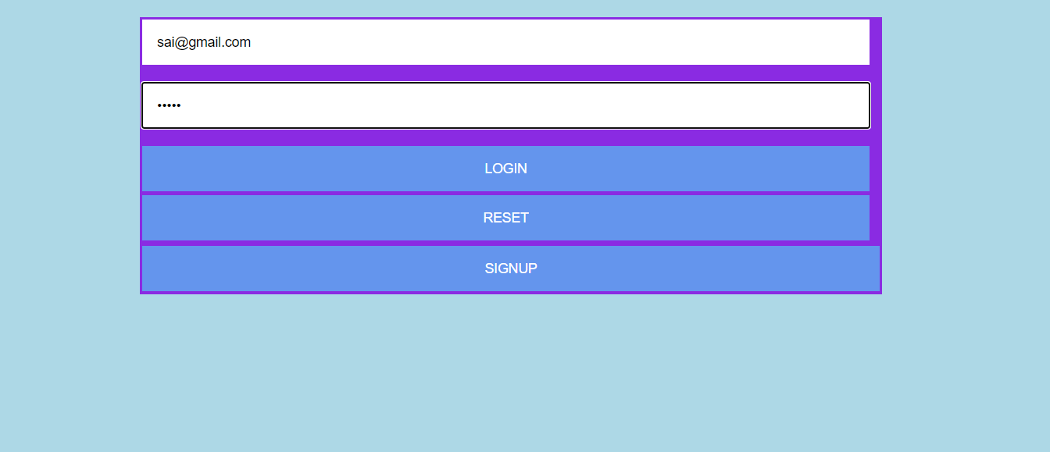

REGISTRATION:

ADMIN LOGIN:

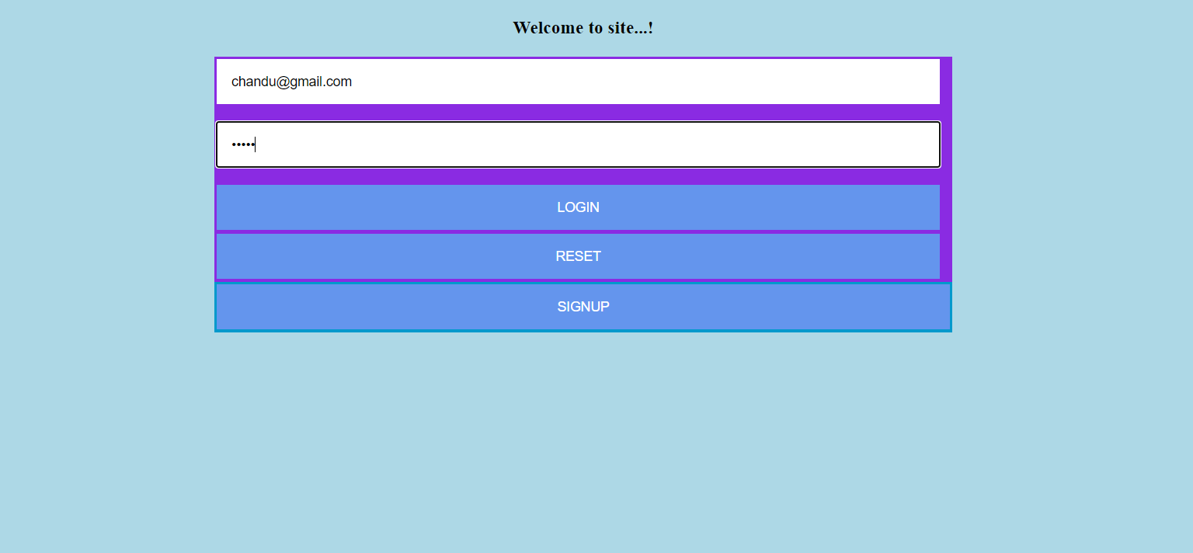

ADMIN REGISTRATION:

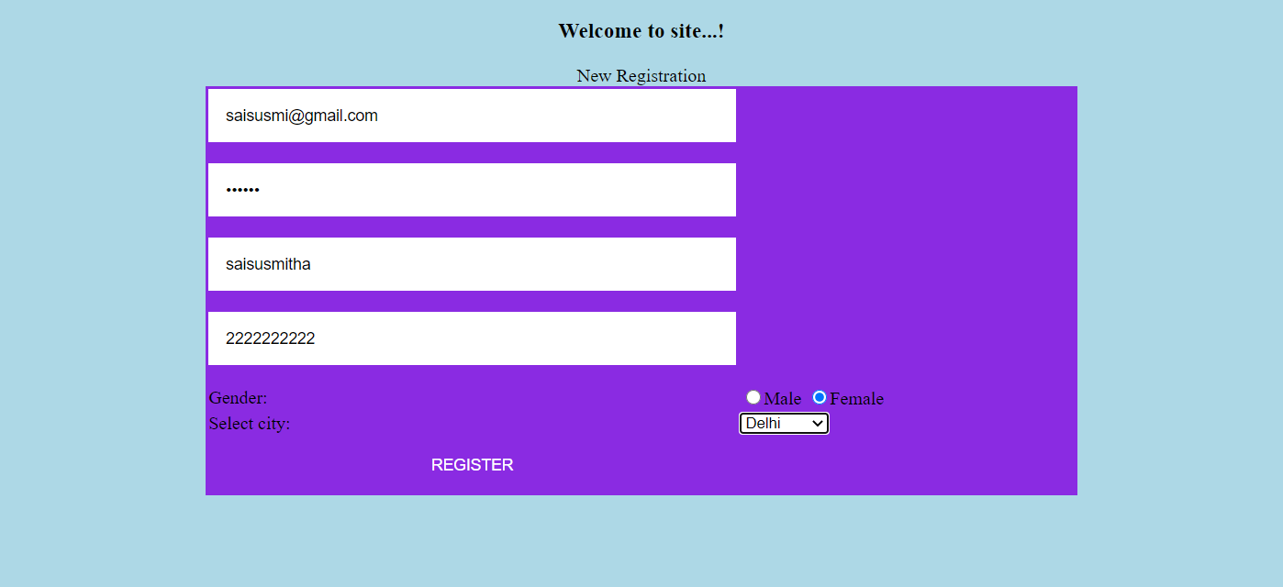

INSTRUCT PAGE:

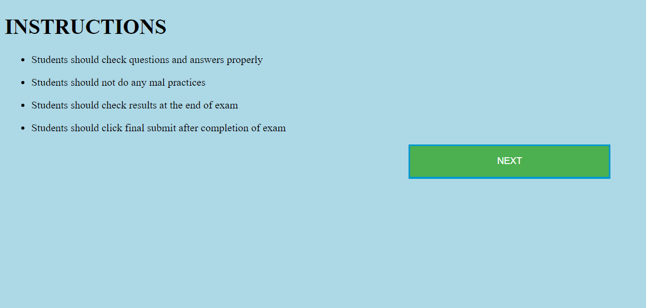

QUESTION PAPER:

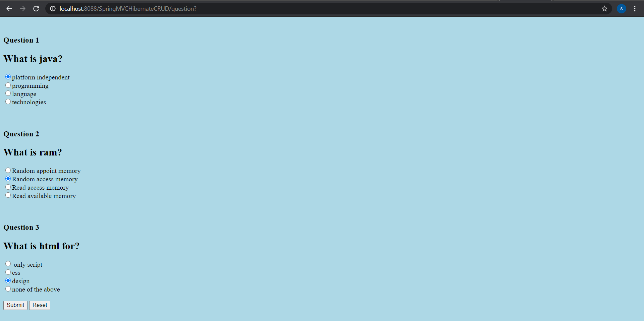

RESULT:

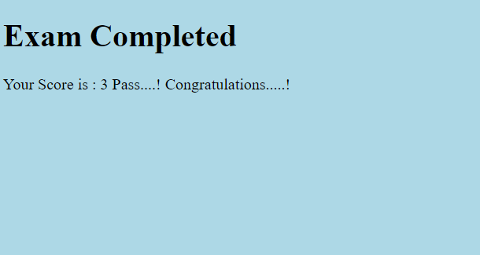

DATABASES:

